Practical 1

# Network commands and their description

## Ipconfig

Displays all current TCP/IP config values. For example IP address, DNS servers, Gateways,etc.

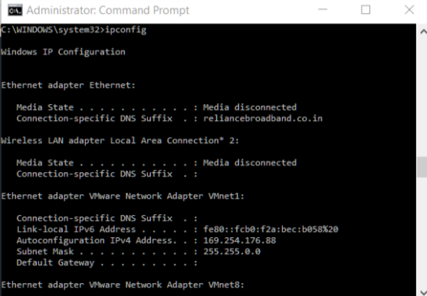

## Ping

Ping is one of the most commonly used network commands that allows you to ping another network IP address. Pinging another address helps determine if the network card can communicate within the local network or outside network.

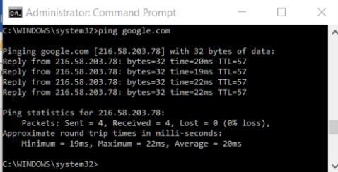

Other options:

-t Ping the specified host until stopped.

-a Resolve addresses to hostnames.

-n count Number of echo requests to send.

-l size Send buffer size.

-f Set Don't Fragment flag in packet (IPv4-only).

-i TTL Time To Live.

-v TOS Type Of Service

-r count Record route for count hops (IPv4-only).

-s count Timestamp for count hops (IPv4-only).

-j host-list Loose source route along host-list (IPv4-only).

-k host-list Strict source route along host-list (IPv4-only).

-w timeout Timeout in milliseconds to wait for each reply.

-R Use routing header to test reverse route also (IPv6-only).

Per RFC 5095 the use of this routing header has been

deprecated. Some systems may drop echo requests if

this header is used.

-S srcaddr Source address to use.

-c compartment Routing compartment identifier.

-p Ping a Hyper-V Network Virtualization provider address.

-4 Force using IPv4.

-6 Force using IPv6.

## Traceroute

The tracert command in MS-DOS and Windows (known as traceroute in Unix-like operating systems) is a useful tool for diagnosing network issues. It allows you to view a listing of how a network packet travels through the network and where it may fail or slow down. Using this information you can determine the computer, router, switch or other network device possibly causing your network issues.

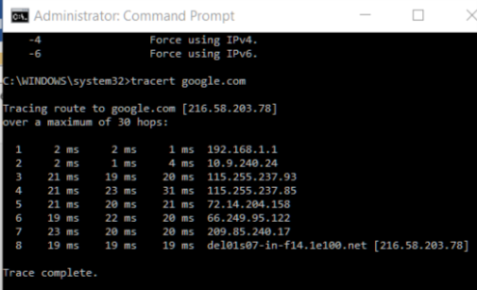

## Nslookup

The nslookup MS-DOS utility that enables a user to do a reverse lookup on an IP address of a domain or host on a network.

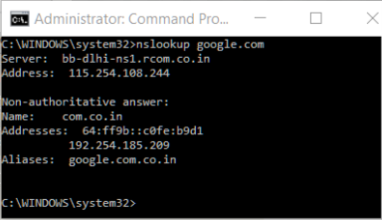

## Finger

The finger command available in Unix and Linux variants allows a user to find sometimes personal information about a user. This information can include the last time the user logged in, when they read their e-mail, etc. If the user creates a .PLAN or other related file the user can also display additional information.

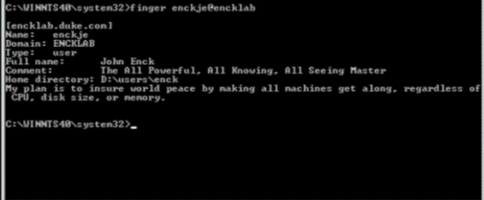

## Arp

Display or manipulate the ARP information on a network device or computer.

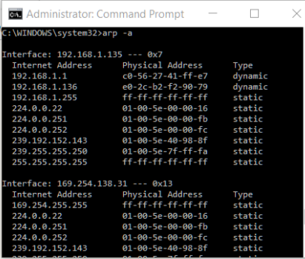

## Netstat

The netstat command is used to display the TCP/IP network protocol statistics and information.

